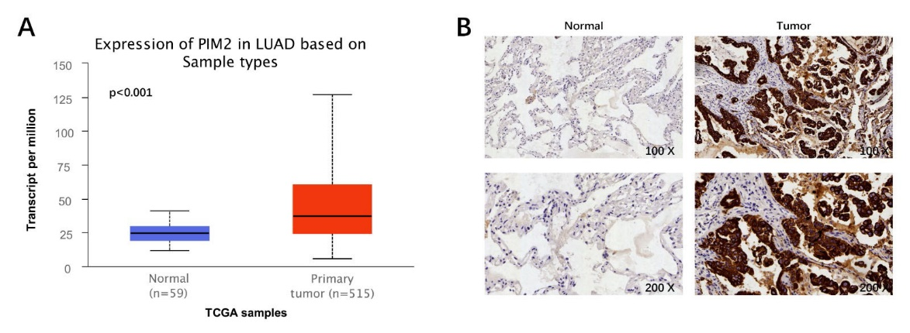
Supplemental Fig. S1. Elevated PIM2 in lung adenocarcinoma. (A) Expression of PIM2 in primary lung adenocarcinoma (N = 515) and normal tissues (N = 59) based on TCGA samples. (B) Expression of PIM2 in primary lung adenocarcinoma tissues and normal tissues detected by immunohistochemical analysis.

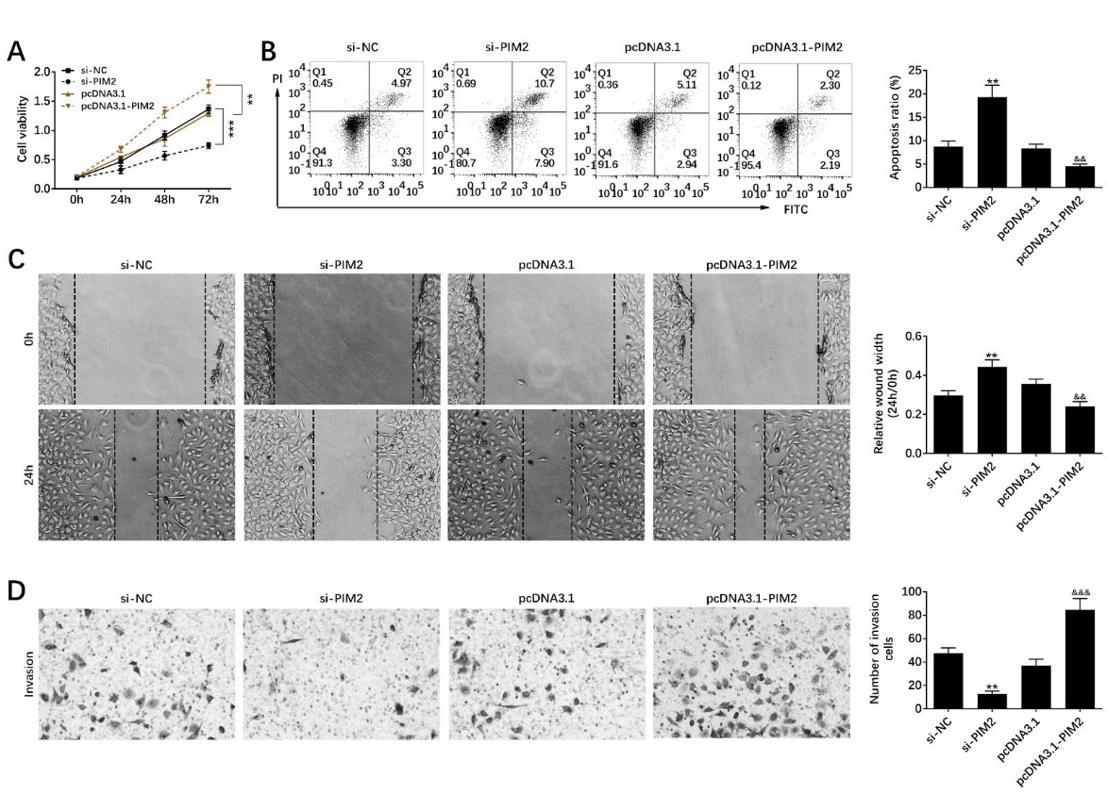
Supplemental Fig. S2. Elevated PIM2 repressed lung adenocarcinoma cell apoptosis and promoted the migration and invasion. (A) Cell viability of H1975 induced by transfecting pcDNA and siRNA of PIM2. (B) Cell apoptosis of H1975 induced by transfecting pcDNA and siRNA of PIM2. (C) Cell migration of H1975 induced by transfecting pcDNA and siRNA of PIM2. (D) Cell invasion of H1975 induced by transfecting pcDNA and siRNA of PIM2. **, && p < 0.01, &&& p < 0.001.

